FIELD REPORT
Introduction
- Place: Agali Seed Secondary School
- Location: Lira city, Agali
- Date of visit: 31st August 2026
- General observations
The verification exercise was conducted with the deputy head teacher, as the head teacher was away attending a workshop. The school was generally well organized, and the deputy head teacher demonstrated good knowledge of the assets received under the UGIFT project, which facilitated the verification process.
When electricity was extended to the school, the connection was limited to the ICT/Library block to support the use of computers. Other school buildings were not connected. The school management subsequently used its own resources to extend electricity to the administration block, including the staff room and administrative offices. However, the remaining school buildings are still without electricity, limiting access to power across the school.
Due to the school’s location within the trading centre, the school shares its toilet facilities with the surrounding community. This presents both health and security concerns, particularly because the school has no perimeter fence to control access to the school premises and its facilities.
During construction, several trees within the school compound were cut down with the understanding that they would be replanted after the construction works. However, according to the Headteacher, the trees have not been replanted to date, leaving the school without the anticipated restoration of its green environment.
The school playground was not levelled as expected during the construction works. As a result, the school management had to use its own resources to level the ground to make the playground usable. This placed an additional financial burden on the school, despite the works reportedly being part of the contractor’s expected scope.
The Headteacher reported that the staff houses were not constructed according to the approved plan. In particular, the dimensions of the houses were reportedly reduced compared to the planned measurements. He further noted that the houses were designed to include wardrobes, but these were not installed. This has affected the adequacy and functionality of the staff accommodation provided.
Challenges
No significant challenges were encountered during the verification exercise.

Special note
At the time of the verification visit, a comprehensive asset register was not available for review. No assets were engraved. The team therefore relied on a letter from the City Office detailing only the ICT items received by the school. This document was used as the primary reference for identifying and verifying the ICT assets observed at the school.
The headteacher reported that he was not fully informed about the specific items, quantities, and other interventions that the school was expected to receive under the UgIFT program. He explained that the details of the planned support were kept confidential, making it difficult for the school management to independently confirm whether all the expected items had been delivered.
The headteacher noted that he is aware of other schools receiving UgIFT support that have additional infrastructure, such as perimeter fencing, which his school does not have. This has raised concerns and uncertainty about whether the school received all the items and infrastructure originally planned under the program. He therefore recommended greater transparency on the approved scope of support and the quantities allocated to each beneficiary school to enable schools to verify and account for the support received.

The table below illustrates some physical status of the verified assets with photographic evidence.
Table XXX: Physical verification photos
AGALI SEED SECONDARY SCHOOL SIGN POST | 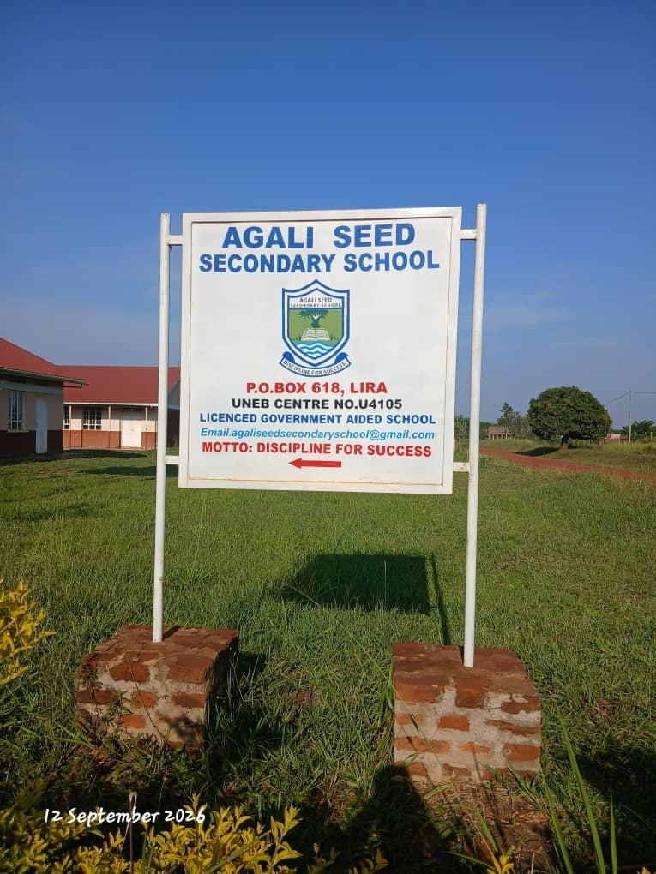
TYPICAL SET OF STAFF QUARTER’S BLOCK  (HOUSE BLOCK WITH TWO UNITS) | 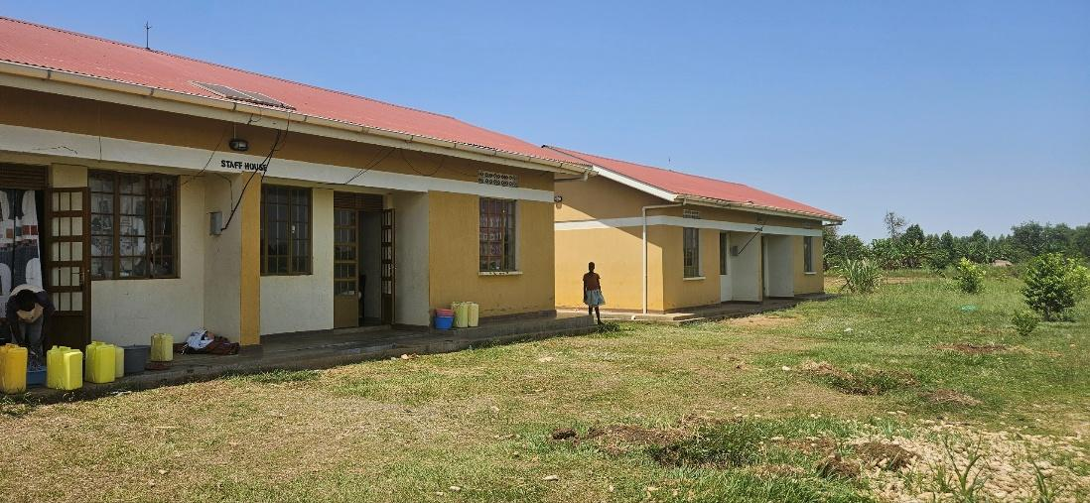
STAFF HOUSE BLOCK, KITCHEN AND TWO STANCE TOILET BLOCK AT THE BACK | 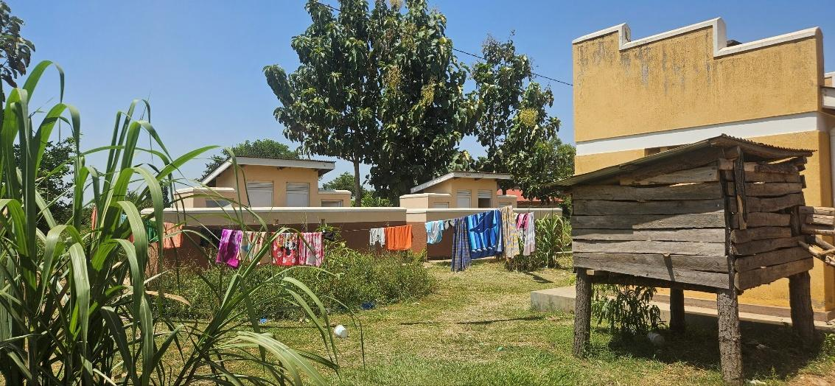
SCIENCE LABORATORY BLOCK WITH TWO UNITS | 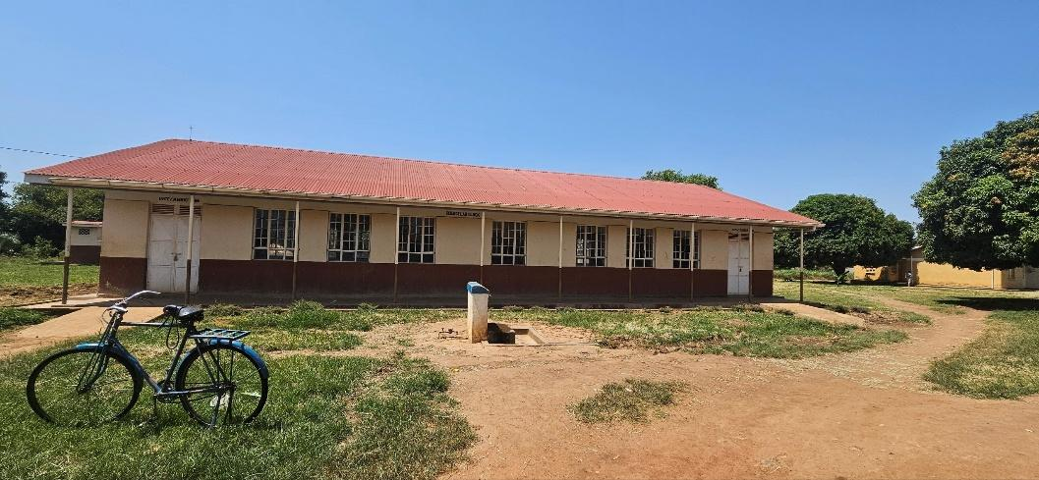
ADMINISTRATION BLOCK WITH TWO UNITS | 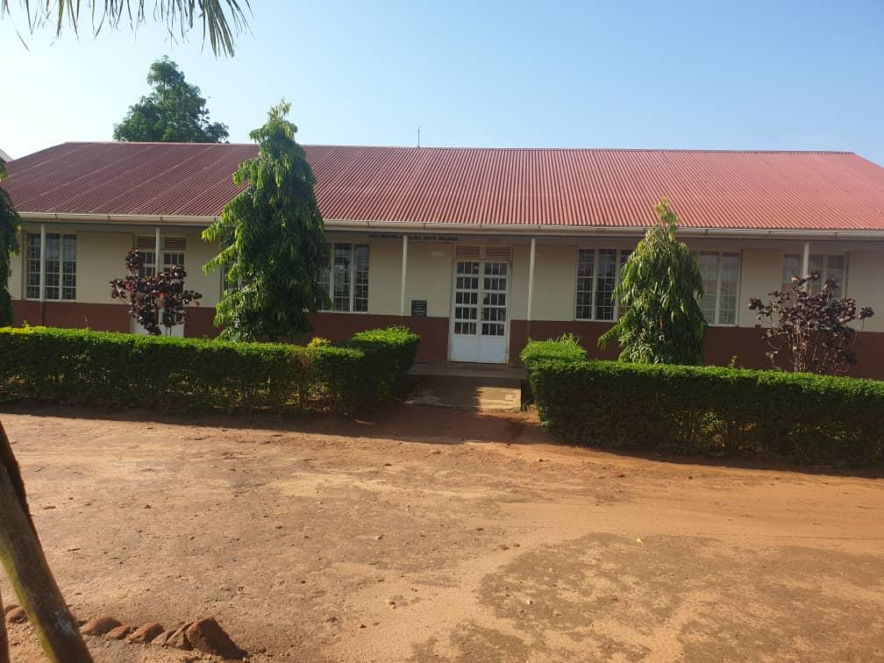
ICT /LIBRARY BLOCK | 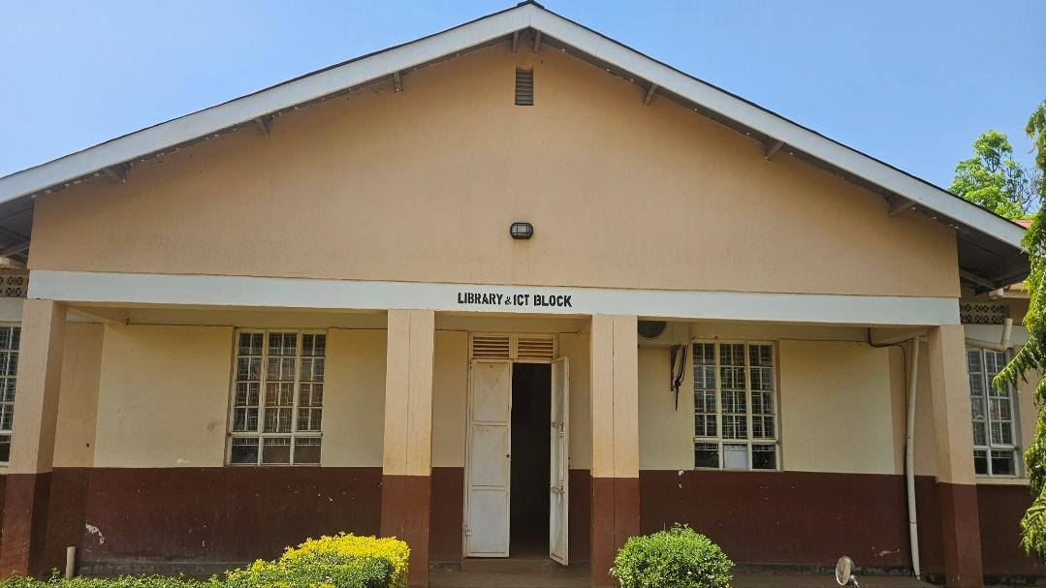
5,000LTRS HDPE CREST TANK WHICH FEEDS A 3,00OLTRS ELEVATED HDPE TANK WITH A PUMP | 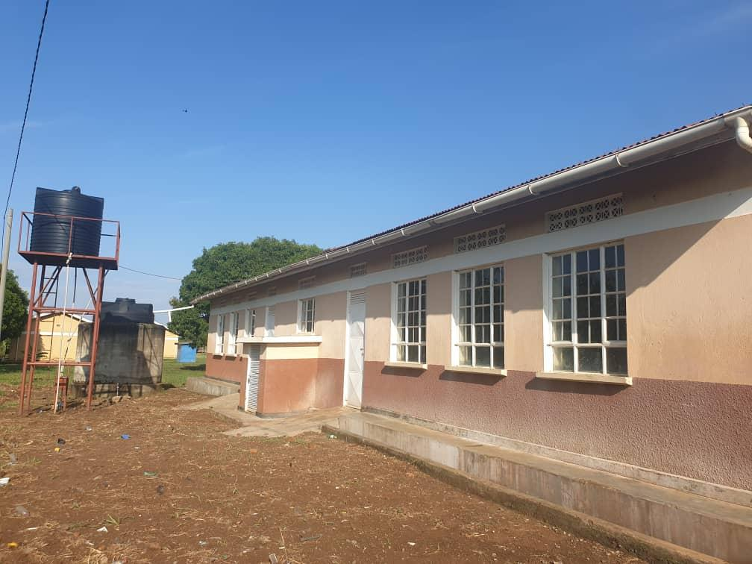
TYPICAL TWO UNITS CLASSROOM BLOCK | 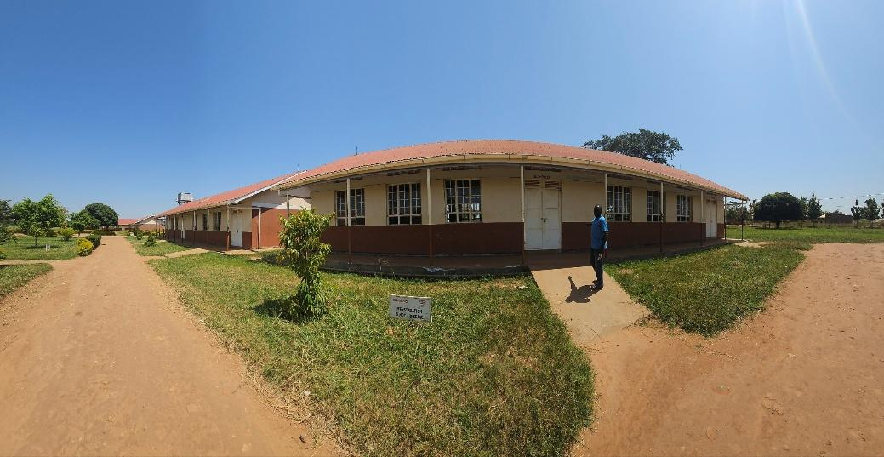
FRONT VIEW OF MULTIPURPOSE HALL | 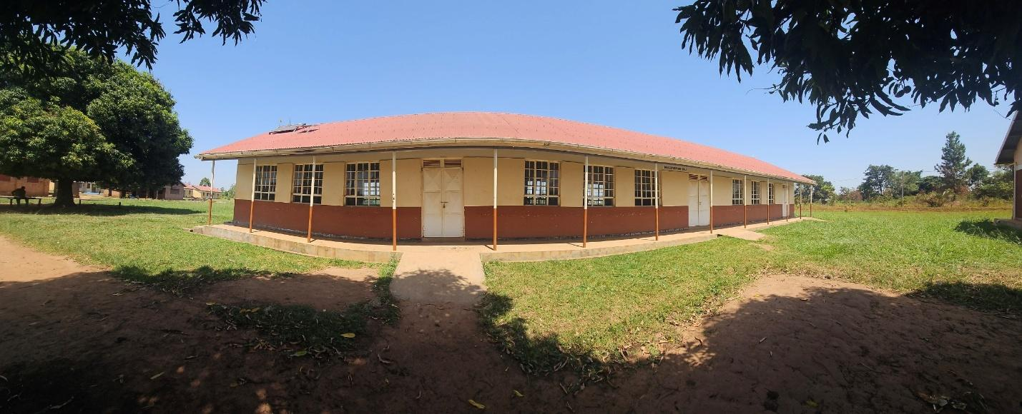
UPS FOR SERVER | 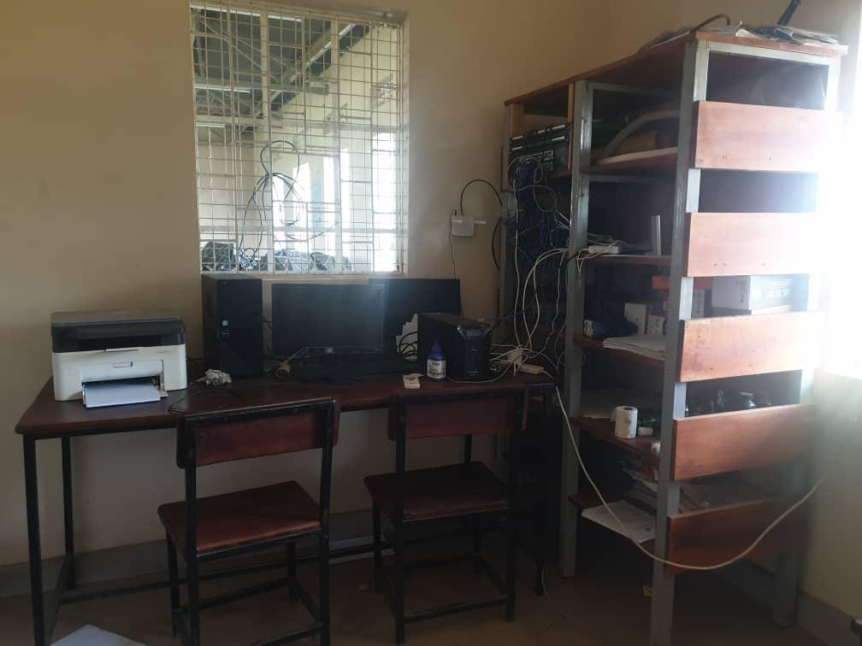
COMPUTER SET (MONITOR, UPS, POWER STABLISER) | 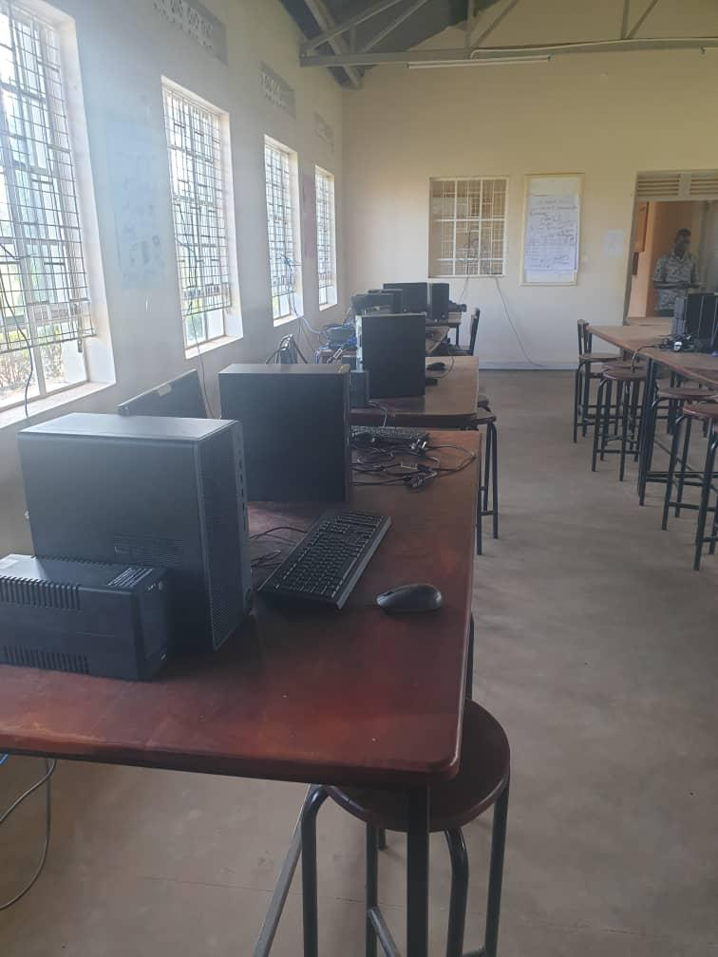
HP-3 IN ONE PRINTER | 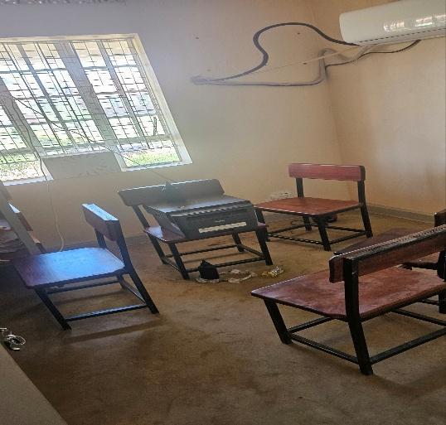
45KG-CYLINDER | 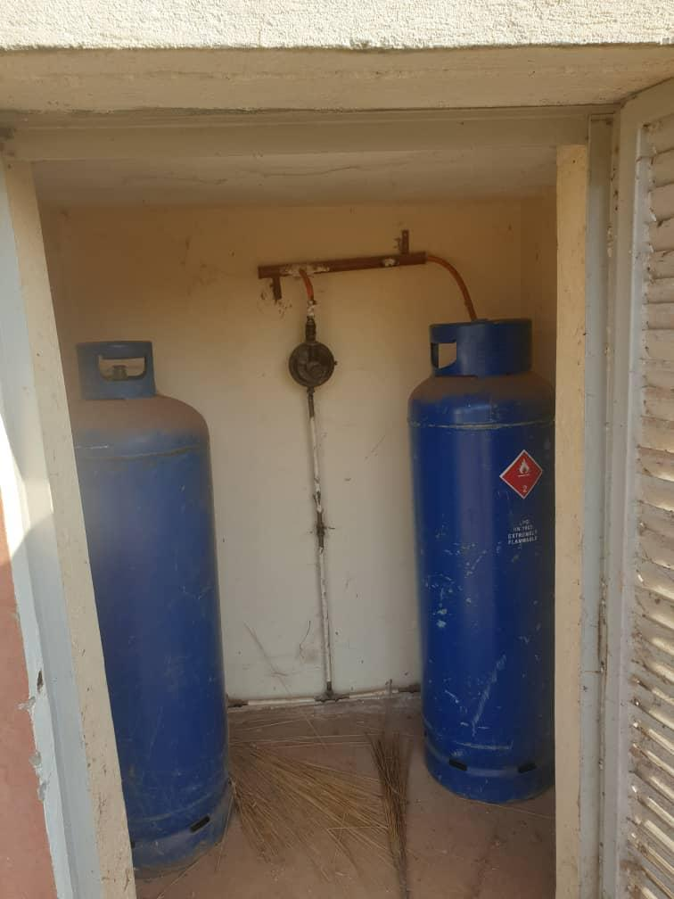
CCT CAMERA-ONE EYE | 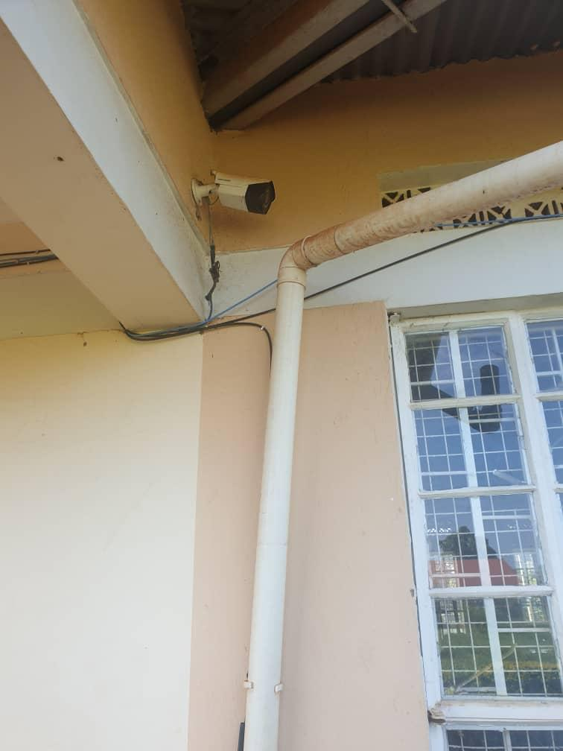
WALL LABORATORY TABLE WITH SHUTTERS, AND SINKS AND WATER CONNECTION | 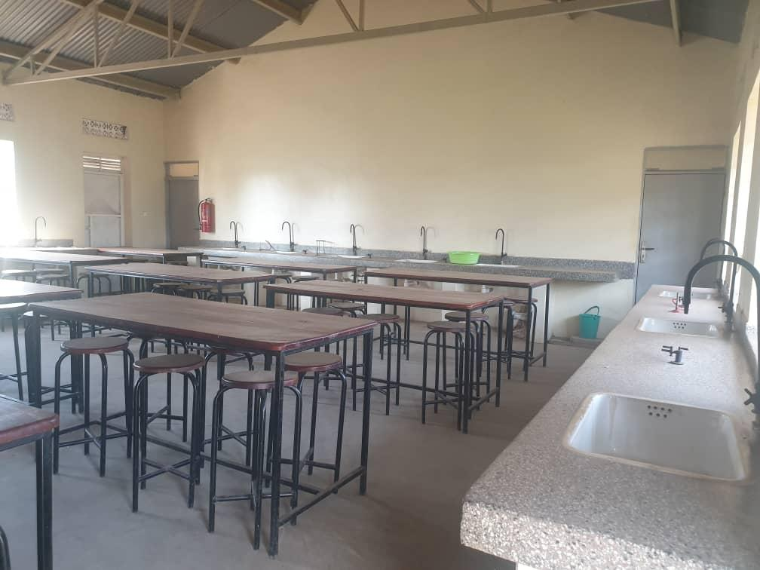
AIR CONDITIONER | 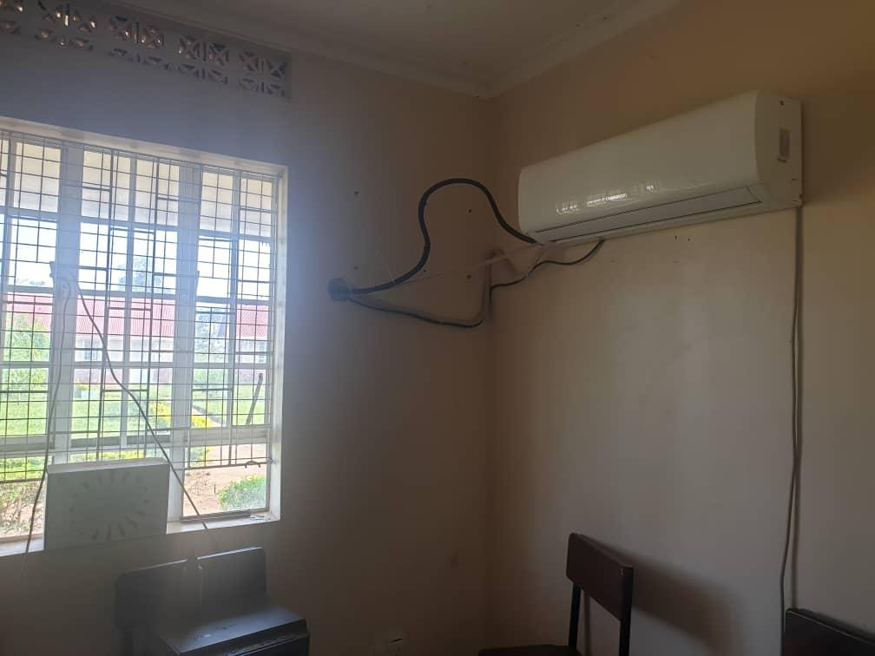
TOILETS WITH 4 STANCES (MALE) | 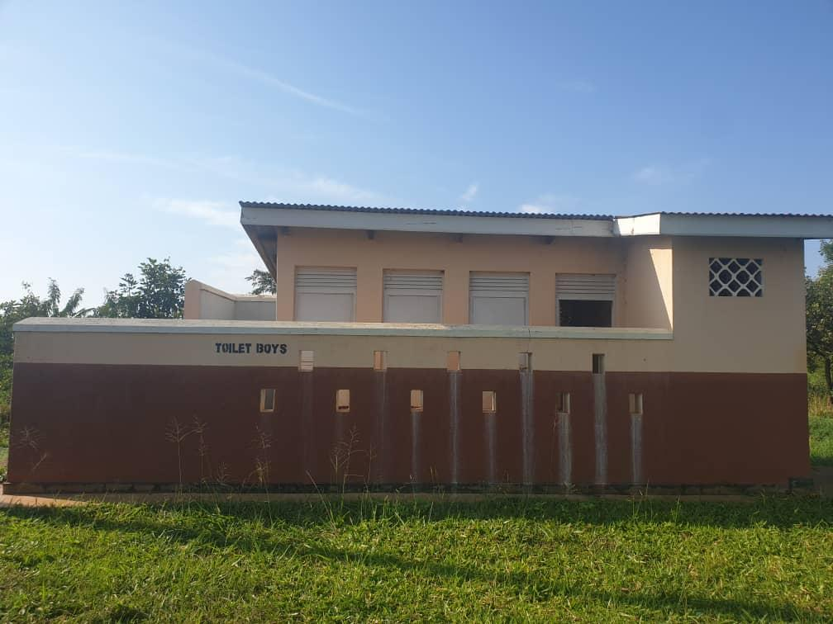
TOILETS WITH 5 STANCES (FEMALE) | 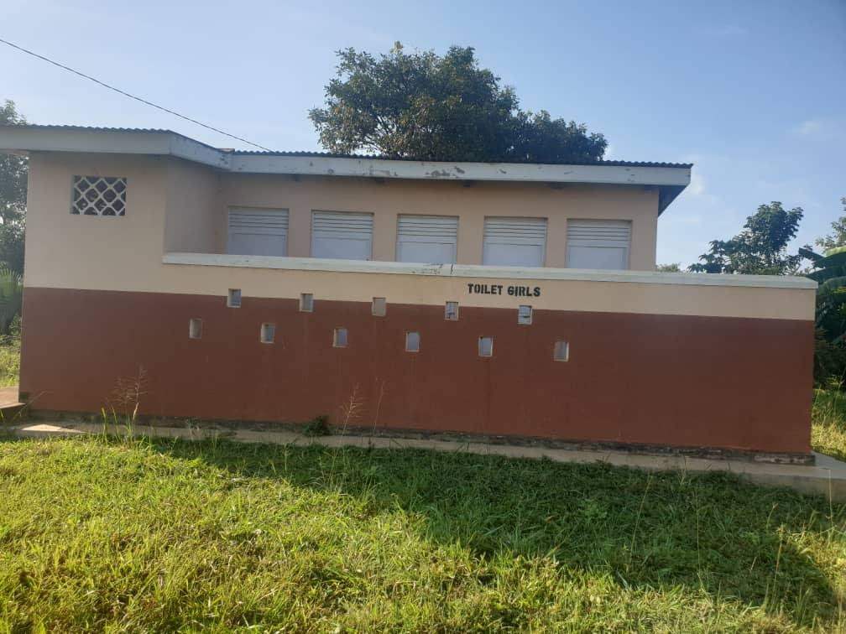
TOILETS FOR SCHOOL STAFF (ONE STANCE EACH) | 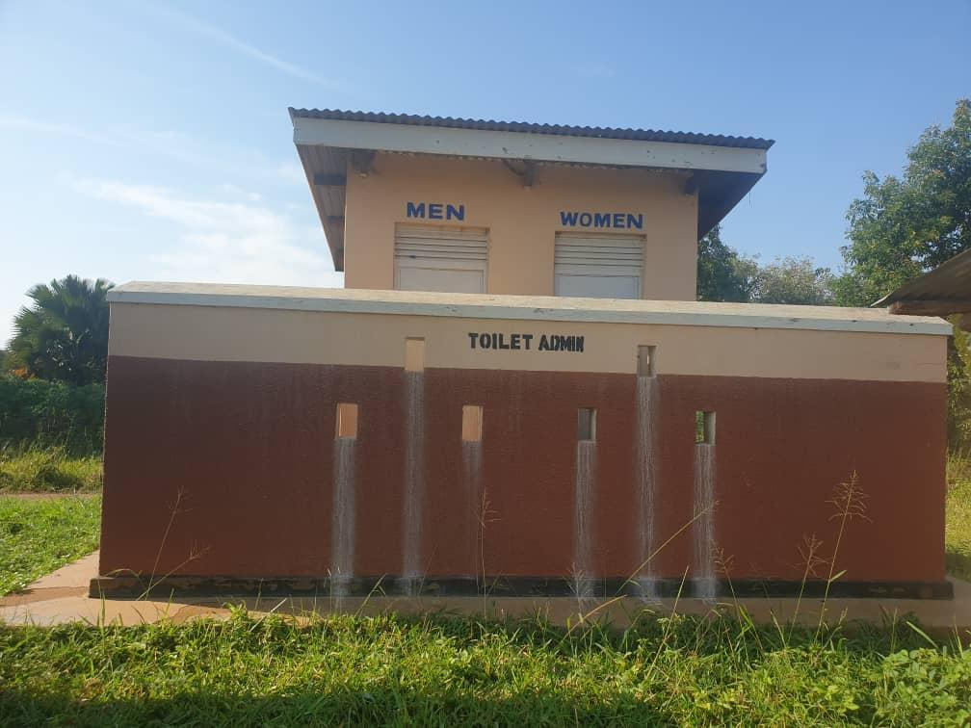
LIBRARY BOOK SHELVES, TABLES AND CHAIRS | 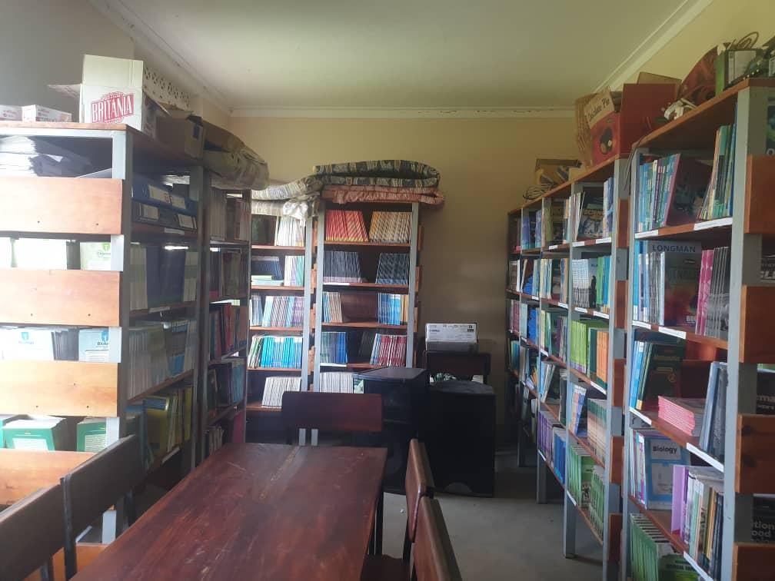
INTERIOR OFTHE COMPUTER LABORATORY | 